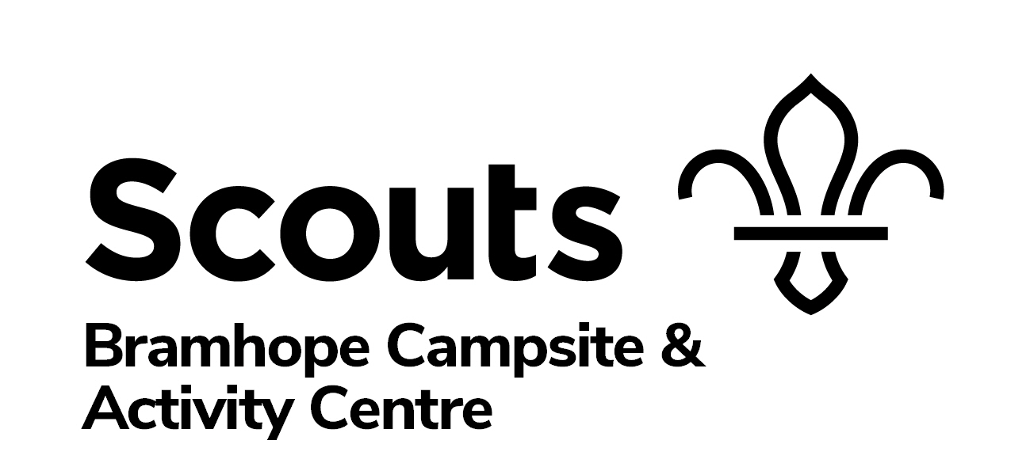
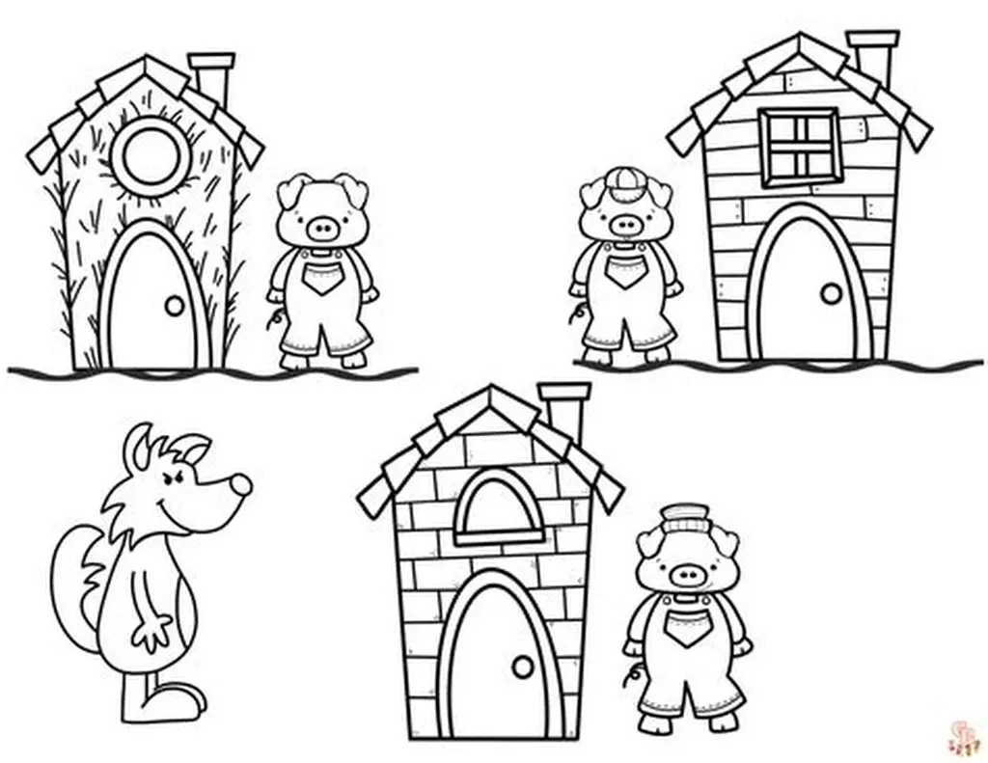
Outdoor Learning
The Three Little Pigs
Reception/Year 1

The EYFS framework encourages creating literacy rich environments where children are immersed in language and stories, in meaningful contexts. It is integrated into all aspects of a child’s learning environment, fostering literacy through everyday interactions, play-based activities and structured learning experiences.
Learning Objectives | Session structure
To explore new places, using a special story map to orienteer around the site  To sequence a story.  To practice using words in the right context. To become increasingly familiar with and retelling traditional tales and stories.  To have the chance to communicate with new people in a different setting. | Introduction  Quick chat about the site, what we are going to be doing, then read the story all seated in the garden area.  Den Building  We collect branches, ropes, tarpaulins together and work in small teams to construct dens to hide in from the big bad wolf.  Fire Making  Develop an understanding of fire safety, what fires need to burn. Collect fuel and then using our flints and steels, make sparks to light a fire.  Finishing game  We play a 3 Little pigs game to end our time together.

We can develop a bespoke package for your visit on request. Altering activities, or introducing new ones.
If schools are travelling in mini-buses and so bring half a class at a time we can provide a fun, low ropes activity for the waiting groups.
Cost for a class visit is £6 per pupil, staff are free of charge.
Session is 10-12, with facilities for groups to stay and have own packed lunch. You are welcome to enjoy Squirrel Square our deisgnated Early years area, which has mud kitchen, mini climbing wall, willow tunnel and equipment for imaginative free play.

