
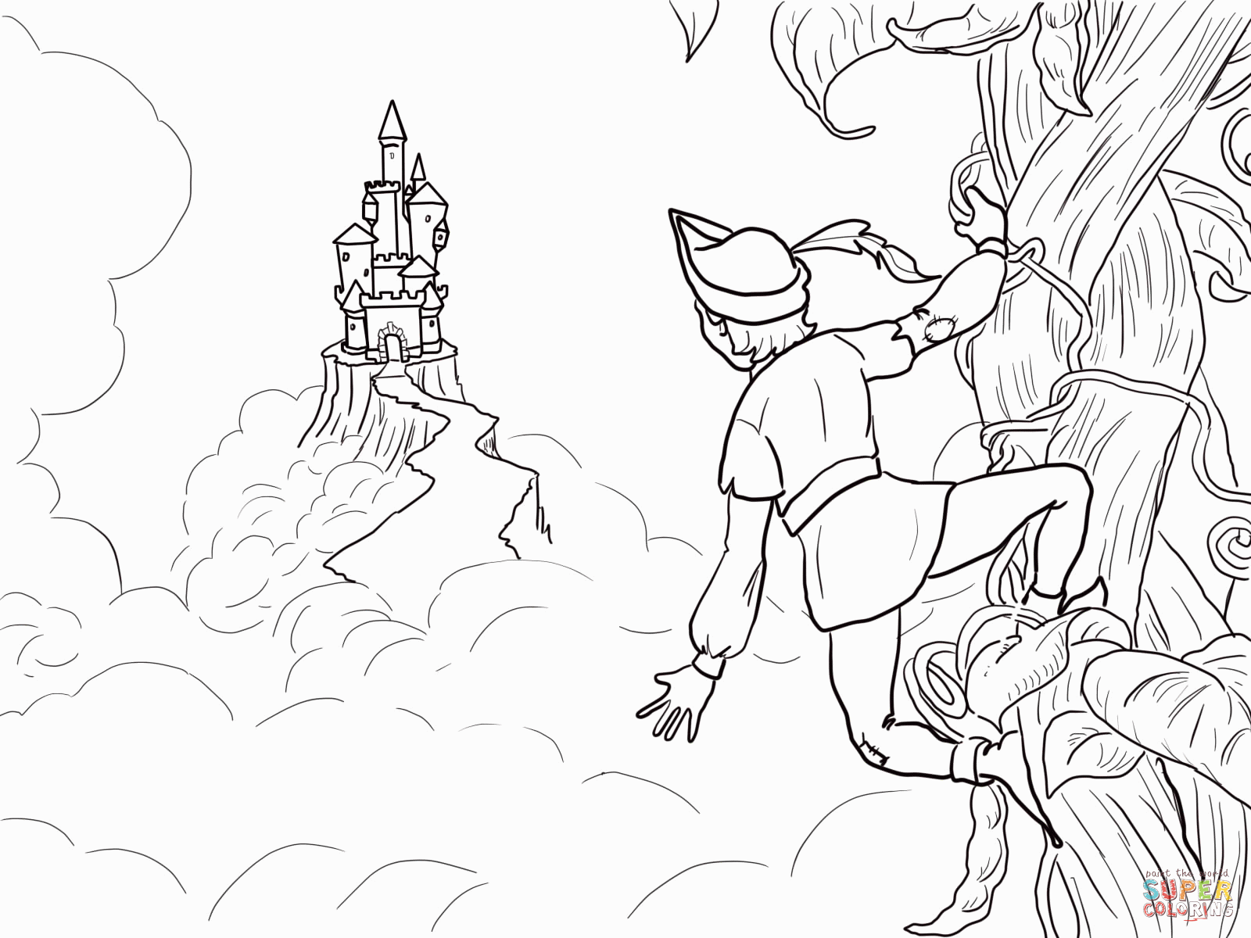
Outdoor Learning
Jack and the Beanstalk
Reception/Year 1

Outdoor Learning enhances children’s learning experiences. Promoting physical activity, emotional well-being and practical skills through interesting hands-on activities in natural settings.

Learning Objectives | Session structure
To explore new places  To develop new skills  To develop understanding of the natural world, where vegetables come from.  To have the chance to work and play cooperatively, taking turns with others. | Introduction  Quick chat about the site, what we are going to be doing, then read the story all seated in the garden area.  Explore  Following a map, wander through the woods, learn how to measure the height of trees, looking out golden eggs along the way. Discover the beans/seeds and plant some into pots to take home. Using resources see how high you can build a beanstalk.  Tomahawk Throwing  Grab your safety axe, just like Jack when he chops down the beanstalk. Take aim at the target, and go for the bullseye. A fun safe activity to practice hand eye co-ordination skills.  Finishing game  A fun game of hide and seek, don’t let the giant find you!!

We can develop a bespoke package for your visit on request. Altering activities, or introducing new ones.
If schools are travelling in mini-buses and so bring half a class at a time we can provide a fun, low ropes activity for the waiting groups.
Cost for a class visit is £6 per pupil, staff are free of charge.
Session is 10-12, with facilities for groups to stay and have own packed lunch. You are welcome to enjoy Squirrel Square our designated Early years area, which has mud kitchen, mini climbing wall, willow tunnel and equipment for imaginative free play.

