
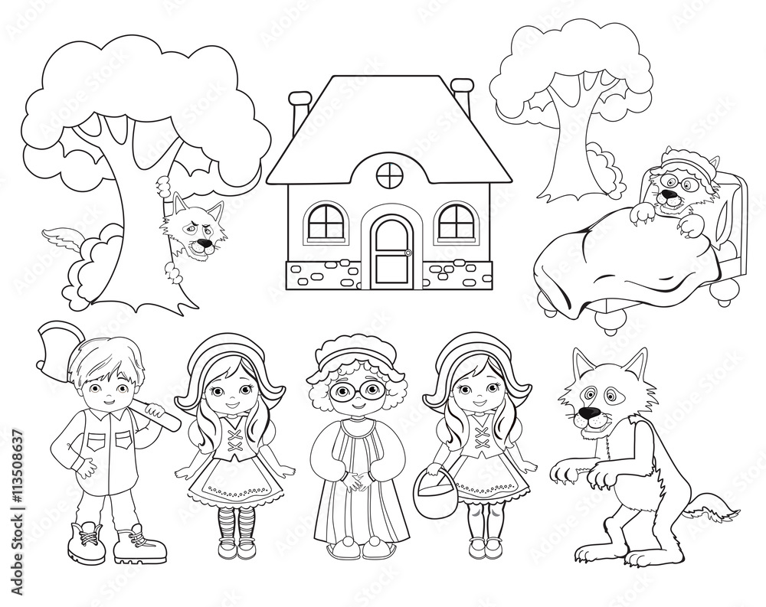
Outdoor Learning
Little Red Riding Hood
Early Years/Reception

The EYFS framework encourages Outdoor Learning to enhance children’s learning experiences. Promoting physical activity, emotional well-being and practical skills through interesting hands-on activities in natural settings.
Learning Objectives | Session structure
To explore new places, using a special story map to orienteer around the site  To develop understanding of ‘stranger danger’  To develop strength and coordination during physical challenges. Negotiating space and obstacles safely.  To have the chance to work and play cooperatively, taking turns with others. | Introduction  Quick chat about the site, what we are going to be doing, then read the story all seated in the garden area.  Orienteering  Following a map, wander through the woods, looking out for the wolf on the way to Grandma’s house. Discuss stranger danger in age appropriate manner. Collect hidden apples along the way.  Tomahawk Throwing  Grab your safety axe, just like Red Riding Hood’s father the Woodcutter. Take aim at the target, and go for the bullseye. A fun safe activity to practice  Finishing game  A fun game of What Time is it Mr Wolf to finish.

We can develop a bespoke package for your visit on request. Altering activities, or introducing new ones.
If schools are travelling in mini-buses and so bring half a class at a time we can provide a fun, low ropes activity for the waiting groups.
Cost for a class visit is £6 per pupil, staff are free of charge.
Session is 10-12, with facilities for groups to stay and have own packed lunch. You are welcome to enjoy Squirrel Square our deisgnated Early years area, which has mud kitchen, mini climbing wall, willow tunnel and equipment for imaginative free play.

