
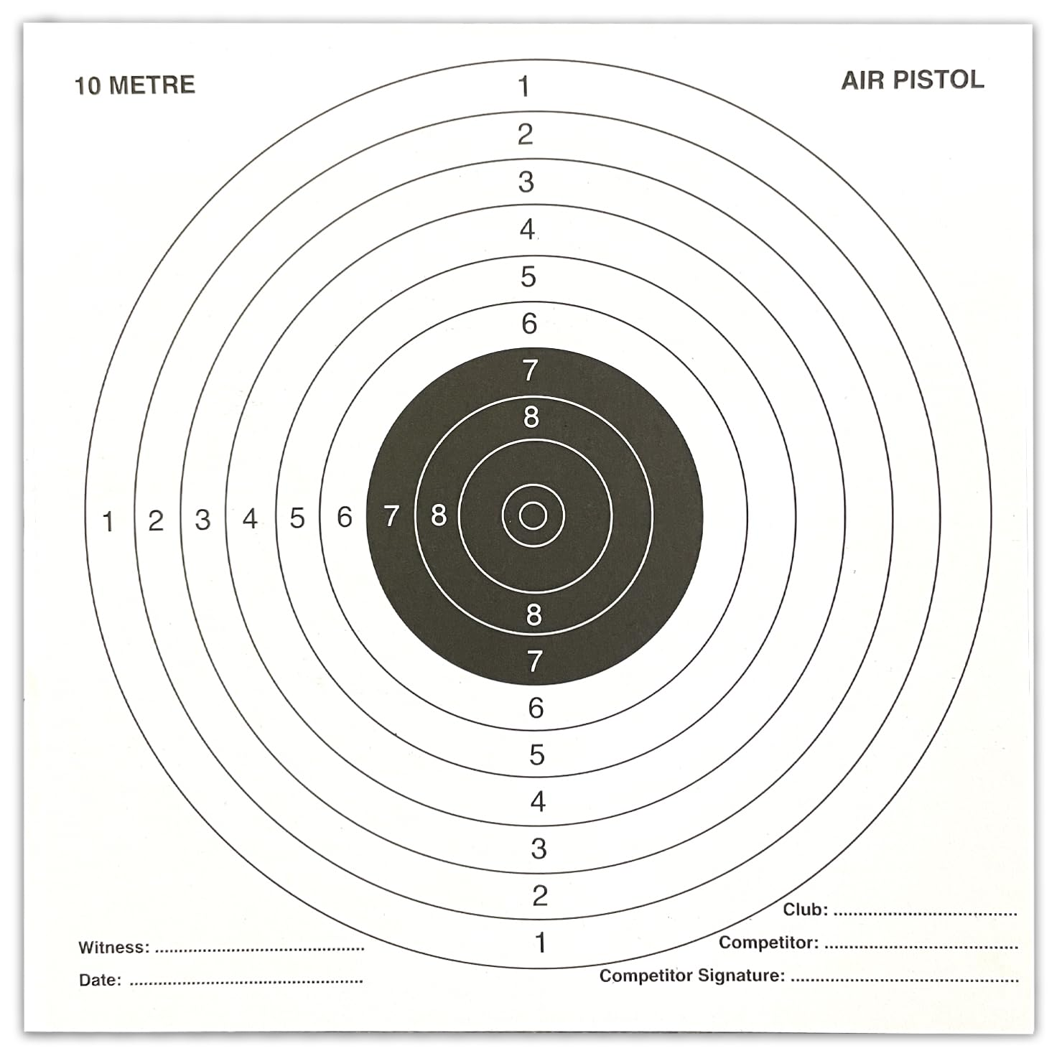

Air Rifles Risk Assessment & Guidance on Responsibilities for Instructors.

Before beginning an instructed session you MUST:

The Air Rifle Range
Check access controls are in place, to control entry to the shooting area, side door MUST be locked to restrict access.
Check pellet catchers are secure.
Set up range positioning tables/chairs following range plan.

Rifles
Visually check for any damage to the rifle, including the barrel, stock and trigger mechanism.
Test the trigger
Check scope is properly mounted and functioning.
Check equipment throughout the activity, removing and reporting any faulty equipment.

Before Session:
All participants under 18 years of age MUST provide a signed parental permission form.
Minimum age for participants is 8 years old.
Middle door to be locked once red light turned on.

After each session:
Ensure range is left tidy and ready for next use. Report any damages.
Eye protection to be replaced in bags and put back onto hooks to prevent scratches.
All equipment to be returned to correct storage location and securely locked.
Damaged equipment to be marked with tape before being securely locked in cupboard.


Risk Assessment

Name of activity, event, and location | Use of Air Rifles @ Bramhope Scout Campsite | Date of risk assessment  Date of next review | 11/5/2026  1/05/2027 | Name of person doing this risk assessment | Angie Foley  John Smallwood

This document describes the hazards and controls you may encounter at Bramhope. This risk assessment excludes adventurous activities, (these are available on our website) and only includes hazards which may affect visiting groups – it does not cover hazards specific to site maintenance volunteers. This document provides a concise overview of the controls in place so that you have a reasonable understanding of the hazards and residual risks associated with visiting the site. If you feel there are hazards missing or you would like more detailed information, please get in touch.

Level | Severity Description | Residual Risk Description
Low | Minor injury requiring no treatment or simple first aid | Control measures have reduced the severity and/or likelihood to minimal levels.
Medium | Injury requires treatment beyond the skills of a basic first aider. Requires participant to stop activity. | Control measures have reduced the severity and/or likelihood to adequate level. But hazard still requires dynamic risk assessment and conscious consideration.
High | Injury requires expert medical attention and/or be fatal. | Control measures haven’t reduced severity or likelihood to an acceptable level.

Hazards | Who may be harmed? | Foreseeable  Severity | Control measures in place | Residual  Risk
Faulty Equipment – risk of cuts/abrasions | All involved in activity | M | Equipment to be stored correctly, locked into rifle cabinet. Rifles to be stored in individual rifle cases.  Qualified instructor to inspect all equipment prior to use  Pellets stored separately from rifles | L
Risk of Rebound | All involved in activity | M | Shooting position MUST be at acceptable distance from target face.  The backstop is checked prior to each use for wear and tear  Shooters & Instructors MUST wear safety goggles during the activity | L
Shooting Control | All involved in activity | L | Induction to activity and ongoing instruction given prior to and throughout the activity by qualified instructor | L
Range layout | All involved in activity | M | The range MUST be secured and laid out in accordance with Scouts P.O.R.  The range MUST be regularly inspected, as well as inspection prior to each use for compliance  Door to range MUST be locked when red shooting light is lit | L
Collection of targets | All involved in activity | H | NO participants to cross the firing line until order has been given by qualified instructors.  All shooting MUST be completed prior to order to move being given.  All rifles MUST be unloaded, broken and laid down on the shooting bench before order given.  Shooters MUST wait until the all clear is given before retrieving targets.  NO shooting must recommence until new targets have been positioned and all participants are back onto the safe side of the shooting line. | M
Trips/Falls | All involved in activity | M | Floor in shooting area to be kept clear of debris & equipment  Floor in waiting area to be kept clear of debris and personal belongings | L
Discipline/Behaviour  Lack of adequate Leader support/behaviour control | All involved in activity | M | Group Leaders to help maintain discipline. Lack of leader support will mean session may be terminated.  Non-shooting participants to be seated in waiting area.  Persistent indiscipline may result in the young person being excluded or the session being terminated | M
Risk of eye injury | All involved in activity | M | All in shooting range MUST wear eye protection at all times  Instruction given on usage of scope, including correct holding position during firing. | L
Crushed fingers/pinched skin | All involved in activity | H | Clear instructions given with regard to handling the rifles.  Remind regularly to keep fingers away from breach mechanism during loading and breaking of the rifle. | M
Risk from pellets | All involved in activity | M | All shooters and instructors to wash hands thoroughly after activity as pellets contain lead. | L

Don‘t forget, as part of your programme planning, you should have contingency activities in reserve just in case you can’t do what was planned or you need to stop half way through. Make sure this is shared with those involved, so everyone knows how to respond. You should have risk assessed contingency activities prior to them taking place and communicated key information to those involved as with all activities.

