
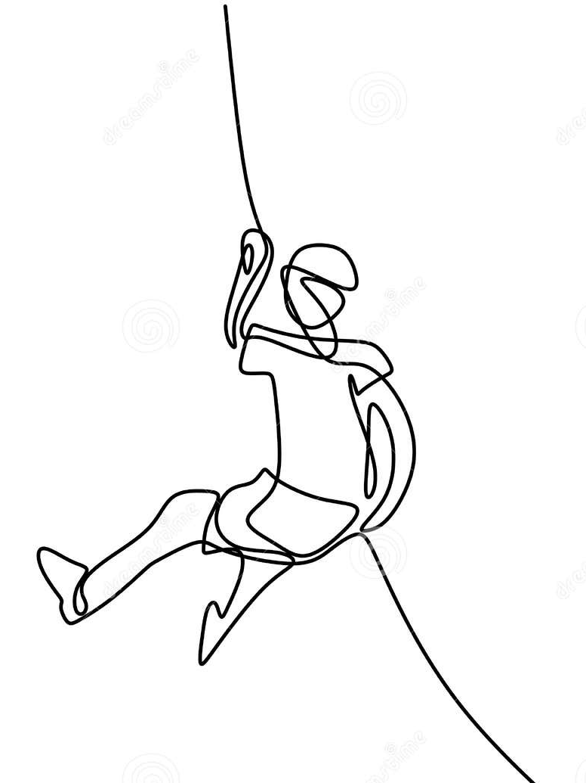

Before beginning an instructed session you MUST:

Crate Stacking area/Climbing Shed hub
Follow Method Statement for rigging the Crate Stacking prior to sessions
Check all equipment before use, remove any that is damaged and isolate.

After each session:
Ensure Crate Stacking area is left tidy and ready for next use. Report any damages and isolate damaged equipment.
Ensure ropes hung to dry if needed. Secure all equipment in the Climbing Hub shed.
Complete log book.


Risk Assessment

Name of activity, event, and location | Use of Crate Stacking @ Bramhope Scout Campsite | Date of risk assessment  Date of next review | 11/05/2026  01/05/2027 | Name of person doing this risk assessment | Angie Foley  John Smallwood

This document describes the hazards and controls you may encounter at Bramhope. This risk assessment excludes adventurous activities, (these are available on our website) and only includes hazards which may affect visiting groups – it does not cover hazards specific to site maintenance volunteers. This document provides a concise overview of the controls in place so that you have a reasonable understanding of the hazards and residual risks associated with visiting the site. If you feel there are hazards missing or you would like more detailed information, please get in touch.

Level | Severity Description | Residual Risk Description
Low | Minor injury requiring no treatment or simple first aid | Control measures have reduced the severity and/or likelihood to minimal levels.
Medium | Injury requires treatment beyond the skills of a basic first aider. Requires participant to stop activity. | Control measures have reduced the severity and/or likelihood to adequate level. But hazard still requires dynamic risk assessment and conscious consideration.
High | Injury requires expert medical attention and/or be fatal. | Control measures haven’t reduced severity or likelihood to an acceptable level.

Hazards | Who may be harmed? | Foreseeable  Severity | Control measures in place | Residual  Risk
General risks | All involved with the activity | H | Only instructors authorised and trained on the equipment may lead the activity (as per list held by Bramhope Scout Campsite Climbing Tower Lead Volunteer)  Training & Assessment framework approved by technical advisor  The activity may only be delivered following the approved Method Statement within the Operations manual | M
Head Injury from bumping or falling equipment/objects | All involved with the activity | M | Persons not involved directly with the activity to stand well clear, outside the rope boundary.  Any person entering the designated area to wear appropriate climbing helmet  Helmets MUST be correctly adjusted and checked by instructor to ensure correct fit.  All climbers to empty pockets and ensure shoes are securely fastened before ascending. | L
Activity & Behaviour Management | All involved with the activity | M | Group Leaders MUST support instructor at all times by maintaining discipline.  Any persistent indiscipline may result in a young person being excluded or the session being terminated | L
Failure of Equipment | All involved with the activity | M | All equipment to be checked prior to use  All equipment to be correctly stored and regularly checked  All equipment to be used in accordance with manufacturers recommendations  Any damaged/faulty equipment to be immediately removed from activity area and reported to Site Manager/Climbing Tower Lead Volunteer & isolated from storage.  Equipment is stored securely, out of direct sunlight and in an area free from any chemicals | L
Falls from height | All involved with the activity | H | Whenever climbing above 1.5m a properly fitting and adjusted harness must be worn and clipped onto an appropriate belay system.  Harnesses MUST be checked and approved by the instructor before use. They MUST NOT be adjusted without instructors permission.  The authorised instructor will check every harness,helmet, knot and karabiner before every ascent.  Peer belaying may only take place with safety back-up under direct supervision of the authorised instructor | M
Falls from height whilst climbing | All involved with the activity | M | Supervision by competent persons who have appropriate site-specific sign-off to instruct on the activity  Authorised instructors ONLY to lower climbers | L
Failure of top anchor | All involved with the activity | M | Anchors to be visually checked prior to use  Anchor installation contains in-built backup. Anchors to be professionally checked annually  Supporting trees to be checked by qualified person as necessary | L
Fingers being caught in anchor shear reduction blocks. Entanglement | Climber | M | Climbers warned to keep fingers away from the anchor  Climbing to cease if climbers become within reaching distance of the top anchor  Ensure long hair is tied back. Loose clothing/neckers to be fastened/removed. securely tucked away. | L
Adverse Weather | All involved with the activity | L | Permitted instructor to advise if weather is appropriate – decision is FINAL  Activity NOT to be used when high winds or thunderstorms forecast | L
Skin Irritation | Anyone wearing a helmet | L | Helmets must only be cleaned according to manufacturers recommendations, which is soap and water  Detergents or sanitising fluids MUST NOT be used | L
Environment  Slips/trips/falls | All involved with the activity | L | Clear briefing given – NO running – Helmets MUST be worn at all times – Appropriate footwear, laces securely tied. 1-2 people ONLY near stack at a time.  Floor area to be made safe before & between climbs – used crates/hazards removed | L
Don‘t forget, as part of your programme planning, you should have contingency activities in reserve just in case you can’t do what was planned or you need to stop half way through. Make sure this is shared with those involved, so everyone knows how to respond. You should have risk assessed contingency activities prior to them taking place and communicated key information to those involved as with all activities.

